3 Programming Interactive Data Visualisation with R
Published
December 4, 2023
Modified
January 31, 2025

3.1 Learning Outcome
In this hands-on exercise, you will learn how to create interactive data visualisation by using functions provided by ggiraph and plotlyr packages.

3.2 Getting Started
First, write a code chunk to check, install and launch the following R packages:
- ggiraph for making ‘ggplot’ graphics interactive.
- plotly, R library for plotting interactive statistical graphs.
- DT provides an R interface to the JavaScript library DataTables that create interactive table on html page.
- tidyverse, a family of modern R packages specially designed to support data science, analysis and communication task including creating static statistical graphs.
- patchwork for combining multiple ggplot2 graphs into one figure.
The code chunk below will be used to accomplish the task.
pacman::p_load(ggiraph, plotly,
patchwork, DT, tidyverse)

3.3 Importing Data
In this section, Exam_data.csv provided will be used. Using read_csv() of readr package, import Exam_data.csv into R.
The code chunk below read_csv() of readr package is used to import Exam_data.csv data file into R and save it as an tibble data frame called exam_data.
exam_data <- read_csv("chap03/data/Exam_data.csv")

3.4 Interactive Data Visualisation - ggiraph methods
ggiraph 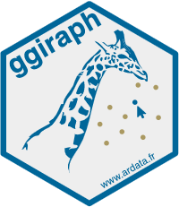 is an htmlwidget and a ggplot2 extension. It allows ggplot graphics to be interactive.
Interactive is made with ggplot geometries that can understand three arguments:
- Tooltip: a column of data-sets that contain tooltips to be displayed when the mouse is over elements.
- Onclick: a column of data-sets that contain a JavaScript function to be executed when elements are clicked.
- Data_id: a column of data-sets that contain an id to be associated with elements.
If it used within a shiny application, elements associated with an id (data_id) can be selected and manipulated on client and server sides. Refer to this article for more detail explanation.

3.4.1 Tooltip effect with tooltip aesthetic
Below shows a typical code chunk to plot an interactive statistical graph by using ggiraph package. Notice that the code chunk consists of two parts. First, an ggplot object will be created. Next, girafe() of ggiraph will be used to create an interactive svg object.
p <- ggplot(data=exam_data,
aes(x = MATHS)) +
geom_dotplot_interactive(
aes(tooltip = ID),
stackgroups = TRUE,
binwidth = 1,
method = "histodot") +
scale_y_continuous(NULL,
breaks = NULL)
girafe(
ggobj = p,
width_svg = 6,
height_svg = 6*0.618
)
Notice that two steps are involved. First, an interactive version of ggplot2 geom (i.e. geom_dotplot_interactive()) will be used to create the basic graph. Then, girafe() will be used to generate an svg object to be displayed on an html page.

3.5 Interactivity
By hovering the mouse pointer on an data point of interest, the student’s ID will be displayed.
255075100MATHS

3.5.1 Displaying multiple information on tooltip
The content of the tooltip can be customised by including a list object as shown in the code chunk below.
exam_data$tooltip <- c(paste0(
"Name = ", exam_data$ID,
"\n Class = ", exam_data$CLASS))

p <- ggplot(data=exam_data,
aes(x = MATHS)) +
geom_dotplot_interactive(
aes(tooltip = exam_data$tooltip),
stackgroups = TRUE,
binwidth = 1,
method = "histodot") +
scale_y_continuous(NULL,
breaks = NULL)
girafe(
ggobj = p,
width_svg = 8,
height_svg = 8*0.618
)
The first three lines of codes in the code chunk create a new field called tooltip. At the same time, it populates text in ID and CLASS fields into the newly created field. Next, this newly created field is used as tooltip field as shown in the code of line 7.

3.6 Interactivity
By hovering the mouse pointer on an data point of interest, the student’s ID and Class will be displayed.
255075100MATHS

3.6.1 Customising Tooltip style
Code chunk below uses opts_tooltip() of ggiraph to customize tooltip rendering by add css declarations.
tooltip_css <- "background-color:white; #<<
font-style:bold; color:black;" #<<

p <- ggplot(data=exam_data,
aes(x = MATHS)) +
geom_dotplot_interactive(
aes(tooltip = ID),
stackgroups = TRUE,
binwidth = 1,
method = "histodot") +
scale_y_continuous(NULL,
breaks = NULL)
girafe(
ggobj = p,
width_svg = 6,
height_svg = 6*0.618,
options = list( #<<
opts_tooltip( #<<
css = tooltip_css)) #<<
)
Notice that the background colour of the tooltip is black and the font colour is white and bold.
255075100MATHS
- Refer to Customizing girafe objects to learn more about how to customise ggiraph objects.

3.6.2 Displaying statistics on tooltip
Code chunk below shows an advanced way to customise tooltip. In this example, a function is used to compute 90% confident interval of the mean. The derived statistics are then displayed in the tooltip.
tooltip <- function(y, ymax, accuracy = .01) {
mean <- scales::number(y, accuracy = accuracy)
sem <- scales::number(ymax - y, accuracy = accuracy)
paste("Mean maths scores:", mean, "+/-", sem)
}

gg_point <- ggplot(data=exam_data,
aes(x = RACE),
) +
stat_summary(aes(y = MATHS,
tooltip = after_stat(
tooltip(y, ymax))),
fun.data = "mean_se",
geom = GeomInteractiveCol,
fill = "light blue"
) +
stat_summary(aes(y = MATHS),
fun.data = mean_se,
geom = "errorbar", width = 0.2, size = 0.2
)

girafe(ggobj = gg_point,
width_svg = 8,
height_svg = 8*0.618)
020406080ChineseIndianMalayOthersRACEMATHS

3.6.3 Hover effect with data_id aesthetic
Code chunk below shows the second interactive feature of ggiraph, namely data_id.
p <- ggplot(data=exam_data,
aes(x = MATHS)) +
geom_dotplot_interactive(
aes(data_id = CLASS),
stackgroups = TRUE,
binwidth = 1,
method = "histodot") +
scale_y_continuous(NULL,
breaks = NULL)
girafe(
ggobj = p,
width_svg = 6,
height_svg = 6*0.618
)
Interactivity: Elements associated with a data_id (i.e CLASS) will be highlighted upon mouse over.
255075100MATHS
Note that the default value of the hover css is hover_css = “fill:orange;”.

3.6.4 Styling hover effect
In the code chunk below, css codes are used to change the highlighting effect.
p <- ggplot(data=exam_data,
aes(x = MATHS)) +
geom_dotplot_interactive(
aes(data_id = CLASS),
stackgroups = TRUE,
binwidth = 1,
method = "histodot") +
scale_y_continuous(NULL,
breaks = NULL)
girafe(
ggobj = p,
width_svg = 6,
height_svg = 6*0.618,
options = list(
opts_hover(css = "fill: #202020;"),
opts_hover_inv(css = "opacity:0.2;")
)
)
Interactivity: Elements associated with a data_id (i.e CLASS) will be highlighted upon mouse over.
255075100MATHS
Note: Different from previous example, in this example the ccs customisation request are encoded directly.

3.6.5 Combining tooltip and hover effect
There are time that we want to combine tooltip and hover effect on the interactive statistical graph as shown in the code chunk below.
p <- ggplot(data=exam_data,
aes(x = MATHS)) +
geom_dotplot_interactive(
aes(tooltip = CLASS,
data_id = CLASS),
stackgroups = TRUE,
binwidth = 1,
method = "histodot") +
scale_y_continuous(NULL,
breaks = NULL)
girafe(
ggobj = p,
width_svg = 6,
height_svg = 6*0.618,
options = list(
opts_hover(css = "fill: #202020;"),
opts_hover_inv(css = "opacity:0.2;")
)
)
Interactivity: Elements associated with a data_id (i.e CLASS) will be highlighted upon mouse over. At the same time, the tooltip will show the CLASS.
255075100MATHS

3.6.6 Click effect with onclick
onclick argument of ggiraph provides hotlink interactivity on the web.
The code chunk below shown an example of onclick.
exam_data$onclick <- sprintf("window.open(\"%s%s\")",
"https://www.moe.gov.sg/schoolfinder?journey=Primary%20school",
as.character(exam_data$ID))

p <- ggplot(data=exam_data,
aes(x = MATHS)) +
geom_dotplot_interactive(
aes(onclick = onclick),
stackgroups = TRUE,
binwidth = 1,
method = "histodot") +
scale_y_continuous(NULL,
breaks = NULL)
girafe(
ggobj = p,
width_svg = 6,
height_svg = 6*0.618)
Interactivity: Web document link with a data object will be displayed on the web browser upon mouse click.
255075100MATHS
Warning
Note that click actions must be a string column in the dataset containing valid javascript instructions.

3.6.7 Coordinated Multiple Views with ggiraph
Coordinated multiple views methods has been implemented in the data visualisation below.
0255075100MATHS0255075100ENGLISH
Notice that when a data point of one of the dotplot is selected, the corresponding data point ID on the second data visualisation will be highlighted too.
In order to build a coordinated multiple views as shown in the example above, the following programming strategy will be used:
- Appropriate interactive functions of ggiraph will be used to create the multiple views.
- patchwork function of patchwork package will be used inside girafe function to create the interactive coordinated multiple views.
p1 <- ggplot(data=exam_data,
aes(x = MATHS)) +
geom_dotplot_interactive(
aes(data_id = ID),
stackgroups = TRUE,
binwidth = 1,
method = "histodot") +
coord_cartesian(xlim=c(0,100)) +
scale_y_continuous(NULL,
breaks = NULL)

p2 <- ggplot(data=exam_data,
aes(x = ENGLISH)) +
geom_dotplot_interactive(
aes(data_id = ID),
stackgroups = TRUE,
binwidth = 1,
method = "histodot") +
coord_cartesian(xlim=c(0,100)) +
scale_y_continuous(NULL,
breaks = NULL)

girafe(code = print(p1 + p2),
width_svg = 6,
height_svg = 3,
options = list(
opts_hover(css = "fill: #202020;"),
opts_hover_inv(css = "opacity:0.2;")
)
)
The data_id aesthetic is critical to link observations between plots and the tooltip aesthetic is optional but nice to have when mouse over a point.

3.7 Interactive Data Visualisation - plotly methods!
Plotly’s R graphing library create interactive web graphics from ggplot2 graphs and/or a custom interface to the (MIT-licensed) JavaScript library plotly.js inspired by the grammar of graphics. Different from other plotly platform, plot.R is free and open source.
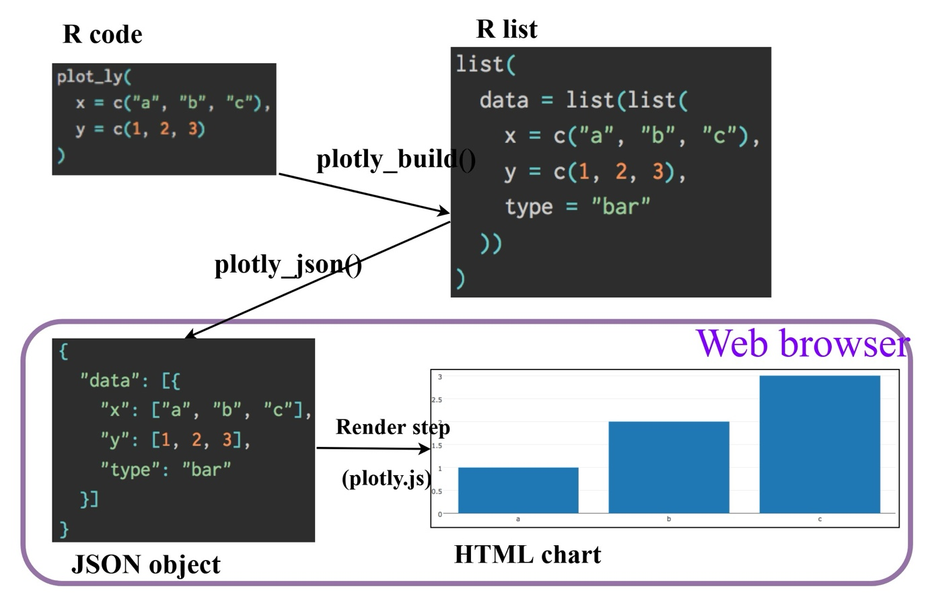
There are two ways to create interactive graph by using plotly, they are:
- by using plot_ly(), and
- by using ggplotly()

3.7.1 Creating an interactive scatter plot: plot_ly() method
The tabset below shows an example a basic interactive plot created by using plot_ly().
- The plot
- The code chunk

3.7.2 Working with visual variable: plot_ly() method
In the code chunk below, color argument is mapped to a qualitative visual variable (i.e. RACE).
- The plot
- The code chunk
Interactive:
- Click on the colour symbol at the legend.

3.7.3 Creating an interactive scatter plot: ggplotly() method
The code chunk below plots an interactive scatter plot by using ggplotly().
- The plot
- The code chunk

3.7.4 Coordinated Multiple Views with plotly
The creation of a coordinated linked plot by using plotly involves three steps:
- highlight_key() of plotly package is used as shared data.
- two scatterplots will be created by using ggplot2 functions.
- lastly, subplot() of plotly package is used to place them next to each other side-by-side.
- The plot
- The code chunk
Click on a data point of one of the scatterplot and see how the corresponding point on the other scatterplot is selected.
Thing to learn from the code chunk:
- highlight_key() simply creates an object of class crosstalk::SharedData.
- Visit this link to learn more about crosstalk,

3.8 Interactive Data Visualisation - crosstalk methods!
Crosstalk is an add-on to the htmlwidgets package. It extends htmlwidgets with a set of classes, functions, and conventions for implementing cross-widget interactions (currently, linked brushing and filtering).

3.8.1 Interactive Data Table: DT package
- A wrapper of the JavaScript Library DataTables
- Data objects in R can be rendered as HTML tables using the JavaScript library ‘DataTables’ (typically via R Markdown or Shiny).
DT::datatable(exam_data, class= "compact")
Show 102550100 entries
Search:
 | ID | CLASS | GENDER | RACE | ENGLISH | MATHS | SCIENCE | tooltip | onclick
1 | Student321 | 3I | Male | Malay | 21 | 9 | 15 | Name = Student321 Class = 3I | window.open("https://www.moe.gov.sg/schoolfinder?journey=Primary%20schoolStudent321")
2 | Student305 | 3I | Female | Malay | 24 | 22 | 16 | Name = Student305 Class = 3I | window.open("https://www.moe.gov.sg/schoolfinder?journey=Primary%20schoolStudent305")
3 | Student289 | 3H | Male | Chinese | 26 | 16 | 16 | Name = Student289 Class = 3H | window.open("https://www.moe.gov.sg/schoolfinder?journey=Primary%20schoolStudent289")
4 | Student227 | 3F | Male | Chinese | 27 | 77 | 31 | Name = Student227 Class = 3F | window.open("https://www.moe.gov.sg/schoolfinder?journey=Primary%20schoolStudent227")
5 | Student318 | 3I | Male | Malay | 27 | 11 | 25 | Name = Student318 Class = 3I | window.open("https://www.moe.gov.sg/schoolfinder?journey=Primary%20schoolStudent318")
6 | Student306 | 3I | Female | Malay | 31 | 16 | 16 | Name = Student306 Class = 3I | window.open("https://www.moe.gov.sg/schoolfinder?journey=Primary%20schoolStudent306")
7 | Student313 | 3I | Male | Chinese | 31 | 21 | 25 | Name = Student313 Class = 3I | window.open("https://www.moe.gov.sg/schoolfinder?journey=Primary%20schoolStudent313")
8 | Student316 | 3I | Male | Malay | 31 | 18 | 27 | Name = Student316 Class = 3I | window.open("https://www.moe.gov.sg/schoolfinder?journey=Primary%20schoolStudent316")
9 | Student312 | 3I | Male | Malay | 33 | 19 | 15 | Name = Student312 Class = 3I | window.open("https://www.moe.gov.sg/schoolfinder?journey=Primary%20schoolStudent312")
10 | Student297 | 3H | Male | Indian | 34 | 49 | 37 | Name = Student297 Class = 3H | window.open("https://www.moe.gov.sg/schoolfinder?journey=Primary%20schoolStudent297")
Showing 1 to 10 of 322 entries
Previous12345…33Next

3.8.2 Linked brushing: crosstalk method
- The plot
- The code chunk
Show 102550100 entries
Search:
 | ID | CLASS | GENDER | RACE | ENGLISH | MATHS | SCIENCE | tooltip | onclick
1 | Student321 | 3I | Male | Malay | 21 | 9 | 15 | Name = Student321 Class = 3I | window.open("https://www.moe.gov.sg/schoolfinder?journey=Primary%20schoolStudent321")
2 | Student305 | 3I | Female | Malay | 24 | 22 | 16 | Name = Student305 Class = 3I | window.open("https://www.moe.gov.sg/schoolfinder?journey=Primary%20schoolStudent305")
3 | Student289 | 3H | Male | Chinese | 26 | 16 | 16 | Name = Student289 Class = 3H | window.open("https://www.moe.gov.sg/schoolfinder?journey=Primary%20schoolStudent289")
4 | Student227 | 3F | Male | Chinese | 27 | 77 | 31 | Name = Student227 Class = 3F | window.open("https://www.moe.gov.sg/schoolfinder?journey=Primary%20schoolStudent227")
5 | Student318 | 3I | Male | Malay | 27 | 11 | 25 | Name = Student318 Class = 3I | window.open("https://www.moe.gov.sg/schoolfinder?journey=Primary%20schoolStudent318")
6 | Student306 | 3I | Female | Malay | 31 | 16 | 16 | Name = Student306 Class = 3I | window.open("https://www.moe.gov.sg/schoolfinder?journey=Primary%20schoolStudent306")
7 | Student313 | 3I | Male | Chinese | 31 | 21 | 25 | Name = Student313 Class = 3I | window.open("https://www.moe.gov.sg/schoolfinder?journey=Primary%20schoolStudent313")
8 | Student316 | 3I | Male | Malay | 31 | 18 | 27 | Name = Student316 Class = 3I | window.open("https://www.moe.gov.sg/schoolfinder?journey=Primary%20schoolStudent316")
9 | Student312 | 3I | Male | Malay | 33 | 19 | 15 | Name = Student312 Class = 3I | window.open("https://www.moe.gov.sg/schoolfinder?journey=Primary%20schoolStudent312")
10 | Student297 | 3H | Male | Indian | 34 | 49 | 37 | Name = Student297 Class = 3H | window.open("https://www.moe.gov.sg/schoolfinder?journey=Primary%20schoolStudent297")
Showing 1 to 10 of 322 entries
Previous12345…33Next

4 Programming Animated Statistical Graphics with R
Published
December 4, 2023
Modified
January 10, 2025

4.1 Overview
When telling a visually-driven data story, animated graphics tends to attract the interest of the audience and make deeper impression than static graphics. In this hands-on exercise, you will learn how to create animated data visualisation by using gganimate and plotly r packages. At the same time, you will also learn how to (i) reshape data by using tidyr package, and (ii) process, wrangle and transform data by using dplyr package.

4.1.1 Basic concepts of animation
When creating animations, the plot does not actually move. Instead, many individual plots are built and then stitched together as movie frames, just like an old-school flip book or cartoon. Each frame is a different plot when conveying motion, which is built using some relevant subset of the aggregate data. The subset drives the flow of the animation when stitched back together.
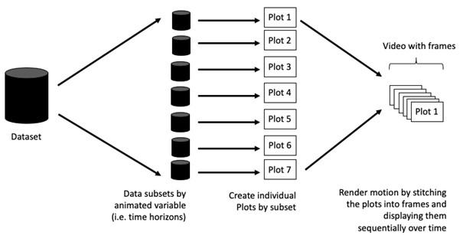

4.1.2 Terminology
Before we dive into the steps for creating an animated statistical graph, it’s important to understand some of the key concepts and terminology related to this type of visualization.
- Frame: In an animated line graph, each frame represents a different point in time or a different category. When the frame changes, the data points on the graph are updated to reflect the new data.
- Animation Attributes: The animation attributes are the settings that control how the animation behaves. For example, you can specify the duration of each frame, the easing function used to transition between frames, and whether to start the animation from the current frame or from the beginning.
Tip
Before you start making animated graphs, you should first ask yourself: Does it makes sense to go through the effort? If you are conducting an exploratory data analysis, a animated graphic may not be worth the time investment. However, if you are giving a presentation, a few well-placed animated graphics can help an audience connect with your topic remarkably better than static counterparts.

4.2 Getting Started

4.2.1 Loading the R packages
First, write a code chunk to check, install and load the following R packages:
- plotly, R library for plotting interactive statistical graphs.
- gganimate, an ggplot extension for creating animated statistical graphs.
- gifski converts video frames to GIF animations using pngquant’s fancy features for efficient cross-frame palettes and temporal dithering. It produces animated GIFs that use thousands of colors per frame.
- gapminder: An excerpt of the data available at Gapminder.org. We just want to use its country_colors scheme.
- tidyverse, a family of modern R packages specially designed to support data science, analysis and communication task including creating static statistical graphs.
pacman::p_load(readxl, gifski, gapminder,
plotly, gganimate, tidyverse)
package 'gifski' successfully unpacked and MD5 sums checked

The downloaded binary packages are in
C:\Users\tskam\AppData\Local\Temp\RtmpmUQpBG\downloaded_packages
package 'gapminder' successfully unpacked and MD5 sums checked

The downloaded binary packages are in
C:\Users\tskam\AppData\Local\Temp\RtmpmUQpBG\downloaded_packages
package 'transformr' successfully unpacked and MD5 sums checked
package 'gganimate' successfully unpacked and MD5 sums checked

The downloaded binary packages are in
C:\Users\tskam\AppData\Local\Temp\RtmpmUQpBG\downloaded_packages

4.2.2 Importing the data
In this hands-on exercise, the Data worksheet from GlobalPopulation Excel workbook will be used.
Write a code chunk to import Data worksheet from GlobalPopulation Excel workbook by using appropriate R package from tidyverse family.
col <- c("Country", "Continent")
globalPop <- read_xls("chap03/data/GlobalPopulation.xls",
sheet="Data") %>%
mutate_each_(funs(factor(.)), col) %>%
mutate(Year = as.integer(Year))
Things to learn from the code chunk above
- read_xls() of readxl package is used to import the Excel worksheet.
- mutate_each_() of dplyr package is used to convert all character data type into factor.
- mutate of dplyr package is used to convert data values of Year field into integer.
Unfortunately, mutate_each_() was deprecated in dplyr 0.7.0. and funs() was deprecated in dplyr 0.8.0. In view of this, we will re-write the code by using mutate_at() as shown in the code chunk below.
col <- c("Country", "Continent")
globalPop <- read_xls("chap03/data/GlobalPopulation.xls",
sheet="Data") %>%
mutate_at(col, as.factor) %>%
mutate(Year = as.integer(Year))
Instead of using mutate_at(), across() can be used to derive the same outputs.
col <- c("Country", "Continent")
globalPop <- read_xls("chap03/data/GlobalPopulation.xls",
sheet="Data") %>%
mutate(across(col, as.factor)) %>%
mutate(Year = as.integer(Year))

4.3 Animated Data Visualisation: gganimate methods
gganimate extends the grammar of graphics as implemented by ggplot2 to include the description of animation. It does this by providing a range of new grammar classes that can be added to the plot object in order to customise how it should change with time.
- transition_*() defines how the data should be spread out and how it relates to itself across time.
- view_*() defines how the positional scales should change along the animation.
- shadow_*() defines how data from other points in time should be presented in the given point in time.
- enter_*()/exit_*() defines how new data should appear and how old data should disappear during the course of the animation.
- ease_aes() defines how different aesthetics should be eased during transitions.

4.3.1 Building a static population bubble plot
In the code chunk below, the basic ggplot2 functions are used to create a static bubble plot.
ggplot(globalPop, aes(x = Old, y = Young,
size = Population,
colour = Country)) +
geom_point(alpha = 0.7,
show.legend = FALSE) +
scale_colour_manual(values = country_colors) +
scale_size(range = c(2, 12)) +
labs(title = 'Year: {frame_time}',
x = '% Aged',
y = '% Young')
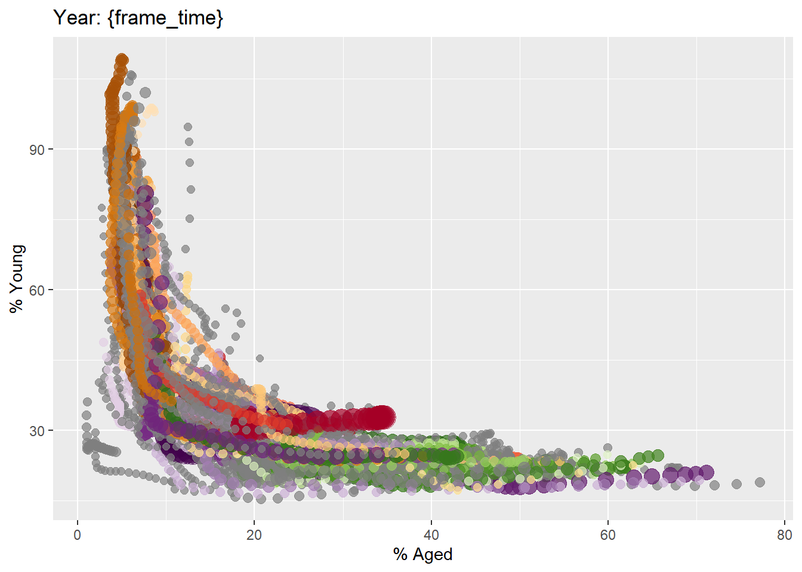

4.3.2 Building the animated bubble plot
In the code chunk below,
- transition_time() of gganimate is used to create transition through distinct states in time (i.e. Year).
- ease_aes() is used to control easing of aesthetics. The default is linear. Other methods are: quadratic, cubic, quartic, quintic, sine, circular, exponential, elastic, back, and bounce.
ggplot(globalPop, aes(x = Old, y = Young,
size = Population,
colour = Country)) +
geom_point(alpha = 0.7,
show.legend = FALSE) +
scale_colour_manual(values = country_colors) +
scale_size(range = c(2, 12)) +
labs(title = 'Year: {frame_time}',
x = '% Aged',
y = '% Young') +
transition_time(Year) +
ease_aes('linear')
The animated bubble chart


4.4 Animated Data Visualisation: plotly
In Plotly R package, both ggplotly() and plot_ly() support key frame animations through the frame argument/aesthetic. They also support an ids argument/aesthetic to ensure smooth transitions between objects with the same id (which helps facilitate object constancy).

4.4.1 Building an animated bubble plot: ggplotly() method
In this sub-section, you will learn how to create an animated bubble plot by using ggplotly() method.
- The plot
- The code chunk
gg <- ggplot(globalPop,
aes(x = Old,
y = Young,
size = Population,
colour = Country)) +
geom_point(aes(size = Population,
frame = Year),
alpha = 0.7,
show.legend = FALSE) +
scale_colour_manual(values = country_colors) +
scale_size(range = c(2, 12)) +
labs(x = '% Aged',
y = '% Young')

ggplotly(gg)
Things to learn from the code chunk above
- Appropriate ggplot2 functions are used to create a static bubble plot. The output is then saved as an R object called gg.
- ggplotly() is then used to convert the R graphic object into an animated svg object.
Notice that although show.legend = FALSE argument was used, the legend still appears on the plot. To overcome this problem, theme(legend.position='none') should be used as shown in the plot and code chunk below.
- The plot
- The code chunk
gg <- ggplot(globalPop,
aes(x = Old,
y = Young,
size = Population,
colour = Country)) +
geom_point(aes(size = Population,
frame = Year),
alpha = 0.7) +
scale_colour_manual(values = country_colors) +
scale_size(range = c(2, 12)) +
labs(x = '% Aged',
y = '% Young') +
theme(legend.position='none')

ggplotly(gg)

4.4.2 Building an animated bubble plot: plot_ly() method
In this sub-section, you will learn how to create an animated bubble plot by using plot_ly() method.
- The plot
- The code chunk
bp <- globalPop %>%
plot_ly(x = ~Old,
y = ~Young,
size = ~Population,
color = ~Continent,
sizes = c(2, 100),
frame = ~Year,
text = ~Country,
hoverinfo = "text",
type = 'scatter',
mode = 'markers'
) %>%
layout(showlegend = FALSE)
bp

